

P.O Box 71150, Nigeria

45 Oduduwa Way, GRA Ikeja, Lagos Nigeria.

Email:

**SALES SHEET**

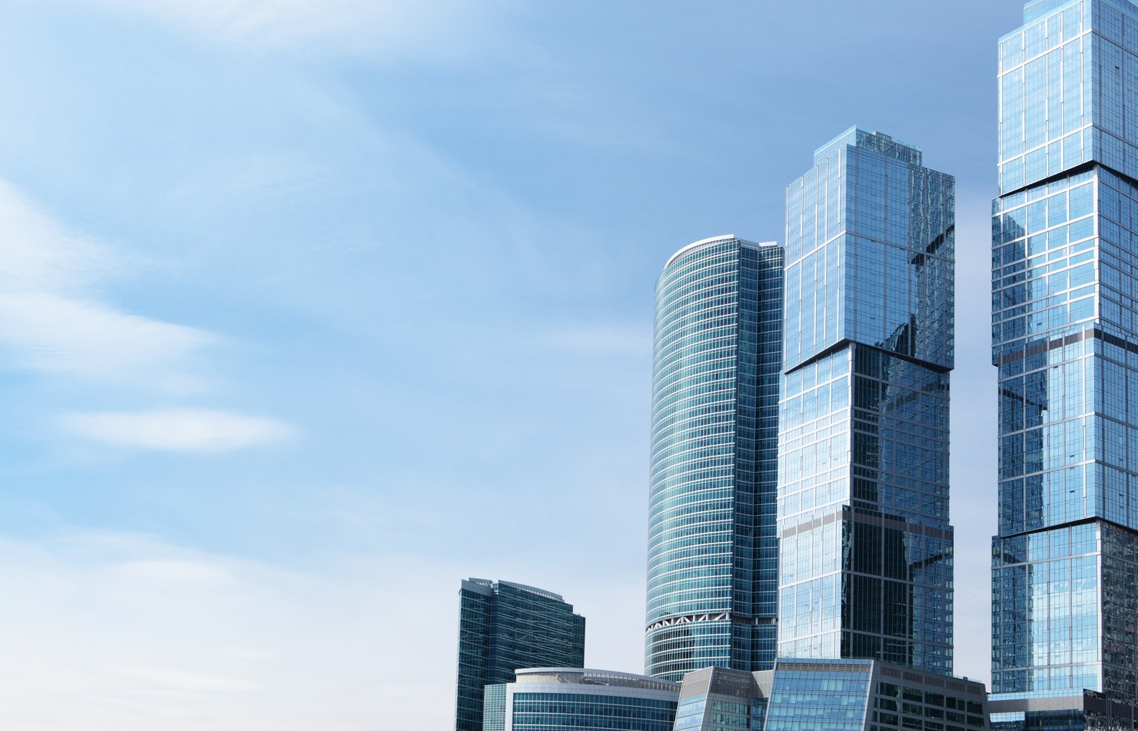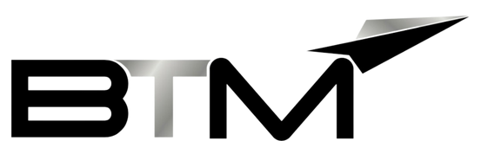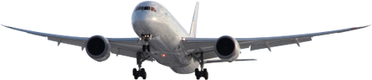

**BUSINESS TRAVEL MANAGEMENT**

**AIRPORT CONCIERGE SERVICE**

The BTM Airport concierge services are personalized travel services that offer assistance and support to travelers at the airport. These services include meet and greet, baggage handling, airport lounge access, fast-track security clearance, and VIP Terminal access.

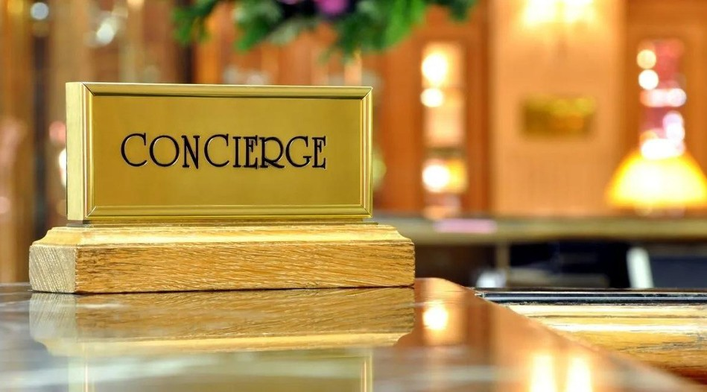

**AIRPORT CONCIERGE**

BTM Nigeria’s Protocol department is wholly owned and operated by BTM. Extensive and Executive Meet & Greet services may be contracted to vetted 3rd party contractors. BTM Nigeria’s protocol Department is able to provide emergency ticket issuances and on-ground airport support 24/7, 365 days a week.

BTM has an extensive range of products and services, which may be specifically tailored to suit each individual client’s requirements.

Included in our bouquet of airport concierge services is the BTM Nigeria Protocol, Meet & Greet service as well as lounge access in Lagos and Abuja.

* BTM helps VIP travelers to enjoy luxurious amenities in exclusive lounges with VIP assistance services
* A Personal assistant will guide you through all airport procedures Enjoy a hassle-free airport travel
* Cut the time spent on airport formalities

**Meet & Greet Process:**



**STANDARD MEET & GREET SERVICE**

* All requests are recorded in the daily travel register.
* Passengers and flights for the next 24 hrs. downloaded and manifested. Manifest is communicated to the Protocol department and on-duty Meet& Greet officers.
* Protocol Officers on duty will be given departure/arrival rosters and schedules for the various passengers as well as airline information; delays, early arrivals, and any cargo requirements for follow-up.
* Confirmation of receipt of Meet & Greet request sent to the various travel booker and departments for assurance.
* All BTM Nigeria protocol staff members are easily identifiable at the airport, in a bold grey vest with the red BTM logo emblazoned on the back, or dark suits with the BTM logo/ badge.

## **VIP and Executive Services**:



**VIP – MEET AND GREET**

* VIP consultants are available and bring additional product value to our executive travelers. BTM Nigeria has a dedicated exceptional protocol team whose duties are to attend to VIP travel requests and demands.
* BTM Nigeria offers our clients various VIP Security options, which include; Helicopter transfers, armed transfers, and bodyguards.
* VIP “meet and greet” is an extensive, seamless, and hassle-free experience where the traveler is assisted from the point of check-in up to the plane door.
* Other enhanced traveler assistance include; cross-border assistance, 24hr personal security, and bodyguards.
* Air charter, as well as Emergency Evacuations services, are also available

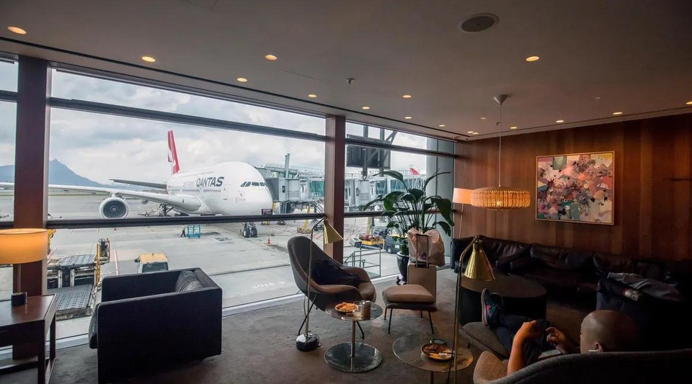

**LOUNGE**

BTM Lounges are the best place, bringing you total peace of mind and a relaxing atmosphere while your stay in the airport.

BTM lounges are open to passengers at a reduced cost no matter the airline they are flying with.

It is the best choice for a connected flight, a canceled flight, an early morning check-in or for breakfast.

BTM lounges are equipped with comfy seats, Food (buffet or snacks) and an assorted selection of drinks, Wi-Fi.

We understand global trends and we have invested substantially through alliances, acquisitions, and the development of new products. We can offer our clients on a need-and-request basis Security and Escort services.

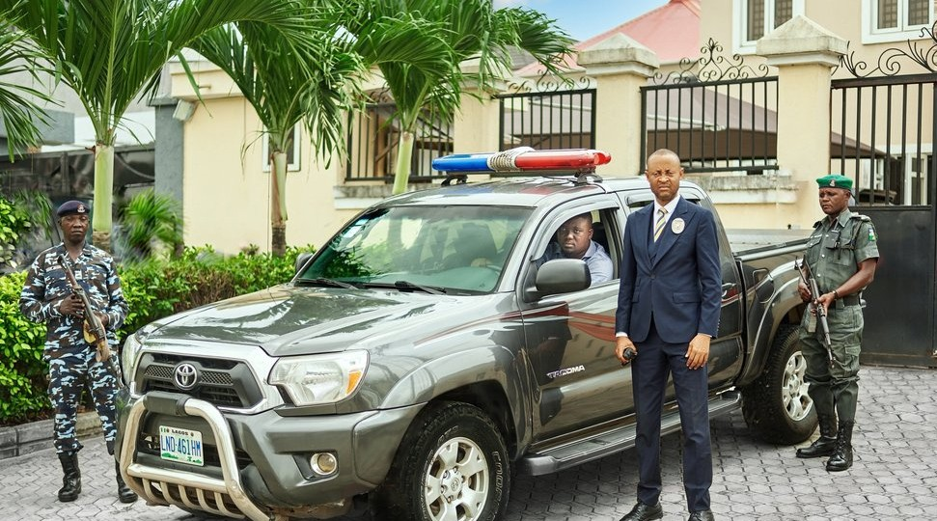

**SECURITY AND ESCORT SERVICES**

* All requests received for security or police escort are registered in the logbook and appropriately arranged.
* Register request in the log book
* Name of passenger/group
* Location to be met
* Time/Date
* Destination
* Passenger/group met at the requested location
* Escorted to the requested location
* Passengers/groups to sign the acknowledgment form.



**Standard Pricing Template:**

**Note: all fees are payable in Naira or USD.**

* Per booking
* Group / Family discount – 25% (Min. 4 Persons)
* Monthly subscription
* Package discounts (50, 100, OR 150 UNITS)



**Standard Pricing Options:**

**Note: all fees are payable in Naira or USD.**

**BE MANAGED BY THE BEST.**

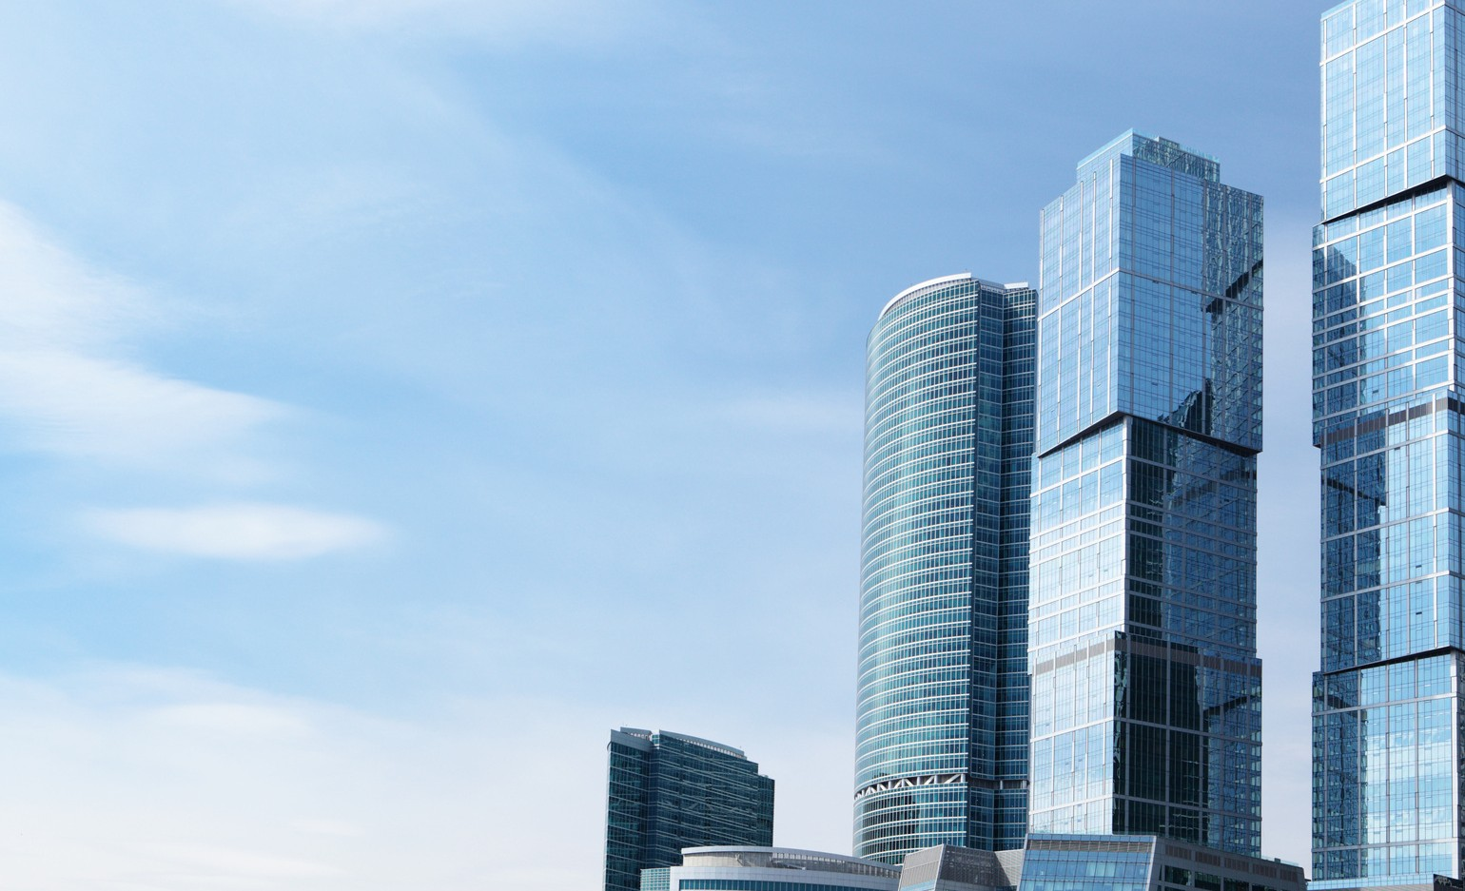

# P.O Box 71150, Nigeria



45 Oduduwa Way, GRA Ikeja, Lagos Nigeria.

Email: [bidresponse@btmlimited.net](mailto:bidresponse@btmlimited.net)